SUBMITTAL DATA SHEET
AUX R32 – C-Series - AJAN18HP230V1C
Job Name | Location Date
Purchaser | Engineer
Submitted to | For □Reference □Approval □Construction
Unit Designation | Schedule #

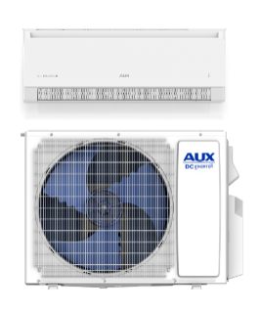
- AHRI No: 214290028

AJAN18HP230V1C

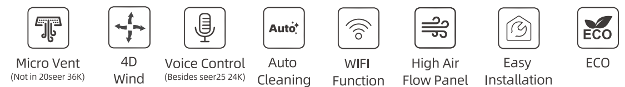

Specifications
Model |  |  |  | AJAN18HP230V1C
Indoor Unit |  |  |  | AJAN18HP230V1CH
Outdoor Unit |  |  |  | AJAN18HP230V1CO
Cooling | Capacity | Rated | Btu/h | 18000
Cooling | Capacity Range | Min-Max | Btu/h | 2900-20000
Cooling | Power Input | Rated | W | 1638
Cooling | Operating Range | °F |  | 5-125
Heating | Capacity at 47F | Rated | Btu/h | 19100
Heating | Capacity Range | Min-Max | Btu/h | 4400-22600
Heating | Power Input at 47F | Rated | W | 1.695
Heating | Capacity at 17F | Rated | Btu/h | 15500
Heating | Capacity at 5F | Max | Btu/h | 14200
Heating | Capacity at -5°F | Max | Btu/h | 10000
Heating | Operating Range | °F |  | -13-75
Efficiency | SEER2 |  |  | 20
Efficiency | HSPF2 |  |  | 9
Indoor Unit | Air Flow Rate(SH/H/M/L/Q) |  | CFM | 560/496/437/378/252
Indoor Unit | Sound Pressure Level | Cooling | dB(A) | 49/46/42/37/29
Indoor Unit | Sound Pressure Level | Heating | dB(A) | 49/46/42/37
Indoor Unit | Package Dimensions | H | In.[mm] | 12-932 [312]
Indoor Unit | Package Dimensions | W | In.[mm] | 42-18 [1070]
Indoor Unit | Package Dimensions | D | In.[mm] | 15-532 [385]
Indoor Unit | Net Dimensions | H | In.[mm] | 8-2532 [223]
Indoor Unit | Net Dimensions | W | In.[mm] | 39-2964 [1002]
Indoor Unit | Net Dimensions | D | In.[mm] | 12-3364 [318]
Indoor Unit | Net Weight | Ibs[kg] |  | 24.2 [11]
Outdoor Unit | Package Dimensions | H | In.[mm] | 24-732 [615]
Outdoor Unit | Package Dimensions | W | In.[mm] | 35-3564 [903]
Outdoor Unit | Package Dimensions | D | In.[mm] | 15-364 [382]
Outdoor Unit | Net Dimensions | H | In.[mm] | 21-5964 [557]
Outdoor Unit | Net Dimensions | W | In.[mm] | 34-4164 [880]
Outdoor Unit | Net Dimensions | D | In.[mm] | 13-5764 [353]
Outdoor Unit | Net Weight | Ibs[kg] |  | 66.1 [30]
Outdoor Unit | Sound Pressure Level | Cooling | dB(A) | 53
Outdoor Unit | Sound Pressure Level | Heating | dB(A) | 55
Piping | Diameter | Gas(0.D.) | In.[mm] | 1/2 [12.7]
Piping | Diameter | Liquid(0.D) | In.[mm] | 1/4 [6.35]
Piping | Diameter | Indoor Drain | In.[mm] | 5/8 [15.88]
Piping | Min.Length | ft [m] |  | 9 [2.74]
Piping | Max.Length | ft [m] |  | 100 [30]
Piping | Max.Height | ft [m] |  | 65 [20]
Electrical | Outdoor-Indoor | V,ph,Hz |  | 208/230,1,60
Electrical | Recommended Breaker Size | A |  | 20
Electrical | MCA | A |  | 15
Electrical | MOCP | A |  | 20
Refrigerant | Refrigerant Type |  |  | R32
Refrigerant | Pre-Charge Amount oz |  |  | 34.6
Refrigerant | Additional Charge Per Foot over 25ft |  |  | 0.258oz/ft
Remarks:
1.All specifications are subject to change by the manufacturer without prior notice.
2.All units are being tested and comply to ISO5151.
3.Sound pressure levels are measured in anechoic chamber.
During actual operation, sound pressure level will be higher as a result of room specification condition.
4.Data from AUX lab,05/03/24, Data may change according to test surroundings, AUX reserves right of explanation on data.



Dimensions
Indoor Unit:
AJAN18HP230V1CH
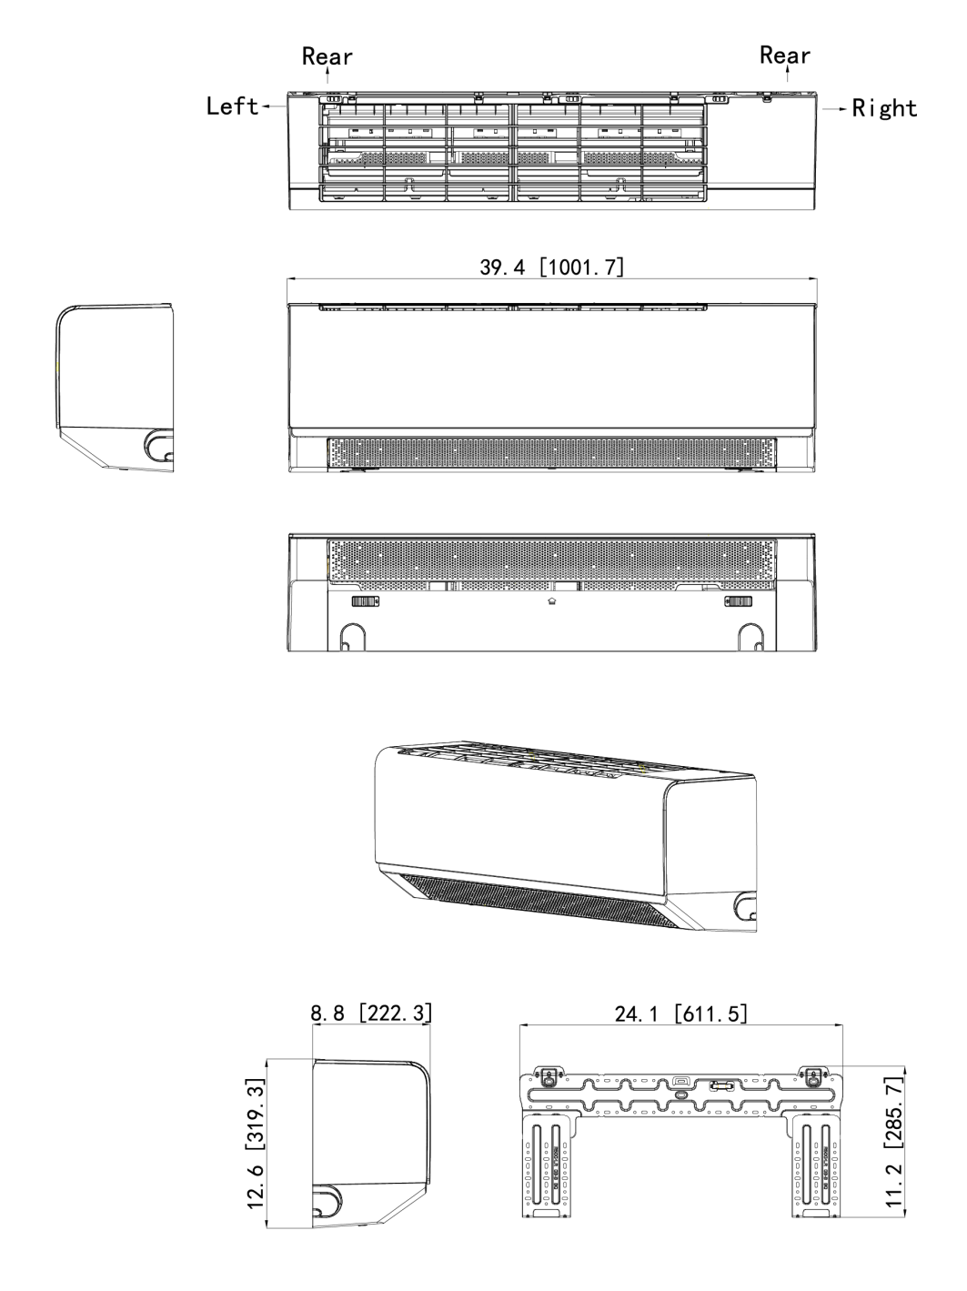
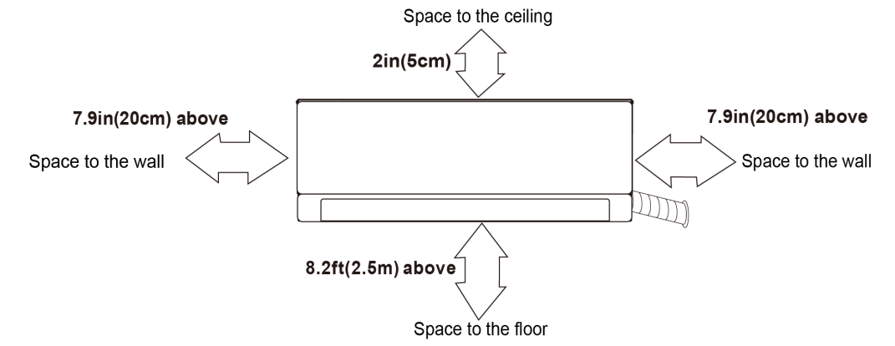

Dimensions
Outdoor Unit:
AJAN18HP230V1CO

Clearances
Outdoor Unit:
AJAN18HP230V1CO
